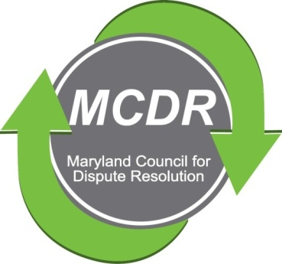

MINUTES OF THE MEETING OF THE EXECUTIVE BOARD OF DIRECTORS

Wednesday, October 2, 2019

PRESENT: Stirling Phillips, Barry Weissman, Janne Weissman, Merry Lymn, David Lewis and Charles Franklin participated by telephone.

NOT PRESENT: Monette Goodridge. There was some confusion about the date of the meeting. Monette received an apology for the mix-up.

The meeting of the Executive Board of Directors of the Maryland Counsel for Dispute Resolution was called to order at 6:15 p.m. and concluded at 6:48 pm.

ELECTION: The entire proposed slate was elected by the membership.

Co-Presidents: David Lewis and Charles Franklin

Immediate Past President: Stirling Phillips

Vice President: Monette Goodridge

Treasurer: Barry Weissman

Secretary: Merry Lymn

Membership Chair: Janne Weissman

Certification Program Chairs: Ramona Buck and Thom McCloud

Program Chair: Laverne Day

Mentoring Chair: Jamie Brooks Robertson

Maryland Bar Liason: Ceecee Paizs

Member At-Large: Liz Salter

The Board decided to name Edie Guidice as Special Advisor to the Board of Directors

SEPTEMBER QUARTERLY MEETING: The venue for the quarterly meeting is the Judicial College of Maryland in Annapolis. Public organizations that are linked in some way to the judiciary may use the facility free of charge.

John Greer will give a one-hour presentation on a toolbox.
David Lewis will make a one-half your presentation about a guided process.
The last half-hour is reserved for questions to the two speakers.

Charles will be taking pictures of this meeting and of future meetings.

FEEDBACK ASSESSMENTS: The assessments were scheduled to assess two people in Largo on Saturday October 5 and three people in Bethesda on October 6. The University of Maryland expressed some interest in participating, but expressed it too late for this set of assessments. They were promised that MCDR would be offering another date sometime in the near future.

LETTERS: The Board asked Janne and Stirling to send the letters that they had drafted to lapsed members and to human resource groups.

DUES: The Board is considering whether to give a discount for dues paid on or before a certain date or to impose a penalty for dues paid after a certain date.

DONATIONS: The Board is considering benefits that can be given to people who donate to the organization.

NEXT BOARD MEETING: November 4, 2019. This will be a meeting of the entire Board. It will be at the home of Barry and Janne Weissman.
Respectfully submitted,

Merry Lymn, Secretary

