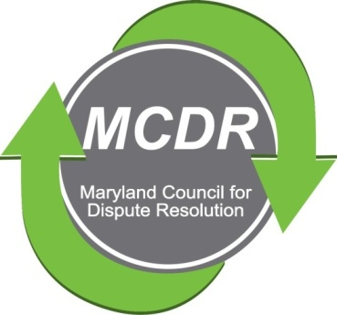

MINUTES OF THE MEETING OF THE BOARD OF DIRECTORS

Sunday, November 18, 2018

PRESENT: Stirling Phillips, Barry Weissman, Merry Lymn, Janne Weissman, Liz Salter, Thom McCloud
NOT PRESENT: Monette Goodridge
The meeting of the Board of Directors of the Maryland Counsel for Dispute Resolution was called to order at 2:00pm. The meeting was conducted by teleconference.
Budget
Barry Weissman, Treasurer, reported that we have enough funds to pay for expenses in the foreseeable future (plaque for the Sharon Pickett award, postcards for distribution at the Convention, rental of meeting space, and possibly speaker fees).
Sharon Pickett Award
The Board decided not to present the Sharon Pickett Award at the December 7 Mediators Convention because MACRO moved the time for the presentation to 8:00 in the morning. The award will be presented to Cam Crockett at the quarterly meeting in January.
Maryland Mediators Convention

MCDR has been assigned booth number 5 at the Maryland Mediators Convention on December 7, 2018. Janne Weissman will manage the booth. She will be sending an email to the membership asking for volunteers for the booth. MACRO has agreed to insert a MCDR postcard into the packet that attendees receive at check-in. Barry will write and arrange for its printing.

January 2019 Quarterly Meeting

The Board decided that the January quarterly meeting will be in Silver Spring. Silver Spring is centrally located and we have a contract with the venue.
The Board decided that the topic for the January meeting should be speaking with people with whom we disagree--civil discourse in the face of disagreement.
Liz, Stirling and Barry agreed to contact individuals whom they know who may be able to suggest a speaker. The Board was also interested in a panel discussion if we can find the appropriate speakers. Anyone who has an idea for a speaker should contact either Stirling or Barry.
The Board expressed a willingness to pay a speaker.
Mentoring Program
Liz agreed to supervise the formation of a mentoring subcommittee of the program committee. Stirling agreed to send an e-mail to the membership of MCDR asking for people to volunteer to serve on the subcommittee.
The Mentoring Initiative flyer will be revised by Barry. He will insert a request for both mentors and mentees.
Stirling will speak with MACRO about its mediation initiative and try to find out why it withered. He will also speak to MACRO about observation opportunities for new mediators.
Stirling agreed to look into the Virginia model.
Liz emphasized that someone needs to talk to the Courts about their observation requirement and negotiate the possibility of fulfilling the requirement by video between a mentor and a mentee who would discuss the video.
Networking outreach event

At the October meeting, Thom proposed using a quarterly meeting as a networking focused meeting. At the November meeting, it was suggested that this be the focus of the March quarterly meeting..

Next Board Meeting: It was suggested, but not decided that the Board might meet at the Convention in December.

Respectfully submitted,

Merry Lymn, Secretary

