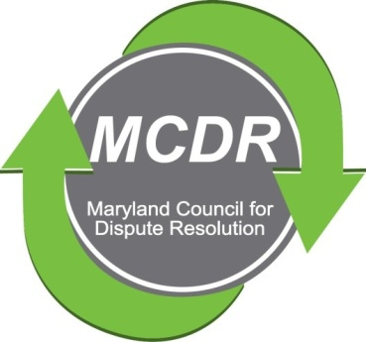

MINUTES OF THE MEETING OF THE BOARD OF DIRECTORS

Sunday, March10, 2019

PRESENT: Stirling Phillips, Barry Weissman, David Lewis, Monette Goodridge, and Janne Weissman

NOT PRESENT: Merry Lymn, Thom McCloud, Liz Salter, Ramona Buck

The meeting of the Board of Directors of the Maryland Counsel for Dispute Resolution was conducted by telephone Sunday, March 10, 2019. Janne Weissman took notes of the meeting discussion.

June Quarterly Meeting

After discussion, the Board decided that the June quarterly meeting will be June 23 from 12:00-4:00. The meeting will include a brunch, the Sharon Pickett Award ceremony, and an educational presentation.

Monette agreed to research space and food options available at several venues suggested by board members. Monette will also finalize the arrangements at the chosen venue.

Program Chair, David Lewis, will plan an educational program.

Next Board Meeting: The next Board meeting is scheduled for 6:00, Sunday, March 31, 2019 at the Weissman's home.

Respectfully submitted,

Merry Lymn, Secretary

