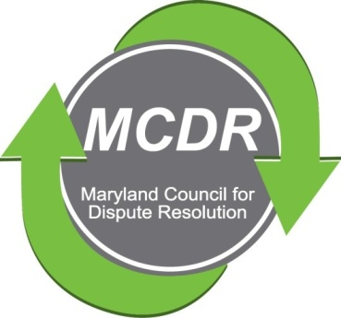

MINUTES OF THE MEETING OF THE BOARD OF DIRECTORS
THURSDAY, SEPTEMBER 1, 2022

PRESENT BY ZOOM: Michael Sallustio, Stirling Phillips, Merry Lymn, Barry Weissman, Janne Weissman, Kate Cullen, and Liz Salter.

The meeting of the Board of Directors of the Maryland Counsel for Dispute Resolution was called to order at 6:00 p.m. and concluded at 7:14 p.m.

PROGRAMS: There were three programs in 2022. A fourth one is planned for November.
The last meeting was a child access meeting that was very successful.

GRANTS: Grants are available from MACRO. However, MCDR’s mentoring program is not quite ready to take advantage of the grant money. It is hoped that our mentoring program will be ready soon and that we will be eligible for a grant in March, 2023.

MENTORING: Stirling Phillips reported that the Mentoring Committee has developed a new format. Mentors and mentees will be paired in accordance with their interests and backgrounds. There will be a six-month pilot program consisting of two cohorts. The cohorts will each contain six individuals--three pairs of mentors/mentees. Once a month one mentor/mentee pair will role play and will receive feedback from the other two pairs in the cohort.

Mentees will receive a 20 percent discount on membership for the first year. Mentors will receive a 20 percent discount when they renew their membership.

If we receive a grant there is a possibility that MCDR could offer a small monetary incentive for recruitment of mentors.

Attached to the minutes, is a a copy of the outline of Collaborative Mediation Coaching Pilot Zoom--To support mediator skills development; To identify/cultivate new and current member engagement; To promote/elevate MCDR profile.

CERTIFICATION: Kate Kranitz reported that the certification committee is working with the Stephen Minnick of the National Academy of Professional Mediators to create national standards and processes for certification. At this time the National Academy of Professional Mediators is developing on seven principles of certification. One of the principles is that the Academy will collaborate with MCDR. MCDR will be performing all of the oral assessments for the Academy. The Academy will be administering a written test as well. There will be an educational requirement. The goal is to meet all international requirements.

MEMBERSHIP: The Board discussed the pros and cons of resuming in-person meetings, perhaps with a hybrid zoom.

MARKETING: The Board decided that there is a need for a standing committee regarding marketing MCDR.

NETWORKING: Janne Wiessman and Liz Salter will meet to formulate networking ideas. opportunities. The Bylaws already provide for a Marketing and Outreach Committee. We simply need to staff it. I agreed to be on it and to reach out to the membership to see who else would be interested.

NOMINATIONS: Michael Sallustio will create a nomination slate in the next few weeks so that ballots can be sent to the membership before the end of September.

NEW BUSINESS: Michael Sllustio will be participating in a Roundtable of Mediation Presidents on November 2, 202, hosted by Steven Boyd Menack, President of APFM. He asked the Board to submit any questions or topics they would like him to raise during that discussion prior to November 2.

NEXT BOARD MEETING: The date of the next board meeting was not set.
Respectfully submitted,

Merry Lymn, Secretary

