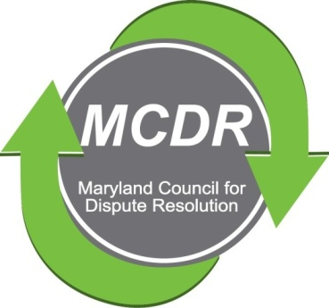

MINUTES OF THE MEETING OF THE BOARD OF DIRECTORS

Sunday, March 29, 2020

PRESENT BY PHONE: Stirling Phillips, Merry Lymn, David Lewis,. Barry Weissman, Janne Weissman, Thom McCloud and Monette Goodridge.

NOT PRESENT: Ramona Buck, Laverne Day, Charles Franklin, Jamie Brooks Robertson, Liz Salter, Ceecee Paizs. (Thom McCloud and Ramona Buck alternate participation).

The meeting of the Board of Directors of the Maryland Counsel for Dispute Resolution was called to order at 6:00 p.m. and concluded at 7:00 pm.

MINUTES OF THE PREVIOUS MEETING were accepted. Stirling suggested an amendment. The Amended Minutes of the January meeting were circulated by e-mail on March 30, 2020.

TREASURER'S REPORT: Barry Weissman culled names from the listserv. This resulted in a $600 savings. Also, he put payments on behalf of MCDR onto his personal credit card. Use of the credit card rather than checks also results in savings.

David asked whether we had paid the annual fee to IMI. Barry said that he needs an invoice. Thom suggested that, before we do anything regarding IMI, the certification committee meet and finalize information needed for IMI.

MENTORING: Stirling is taking over the leadership of the Mentoring Committee. David, Janne, and Monette agreed to serve on the committee. The Committee will meet from 6:00 to 7:00 p.m., Tuesday, April 7, 2020.

CERTIFICATION: A certification session is scheduled for May 3, 2020. One person has applied for certification. Whether or not the session takes place depends upon the current health crisis.

In between the January and March meetings, the Board voted by e-mail to apply for a grant from MACRO. The Certification Committee submitted a proposal. We are waiting for a response.

PROGRAMS: Because of COVID 19, the program for the March quarterly meeting was postponed indefinitely. LaVerne is working to see how the Jeopardy Ethics game can be broadcast by Zoom.

MEMBERSHIP: Janne Weissman, Membership Chair, reported that, she is in contact with both the national organization and the local chapter of the Society of Human Resource Management, SHRM, to set up either a joint meeting or a joint program that would be of interest to the members of that organization and members of MCDR.

NEXT BOARD MEETING: The next meeting of the Board of Directors will take place by telephone Sunday, April 26, 2020 at 6:00 p.m.
Respectfully submitted,

Merry Lymn, Secretary

