Erin Darner Gable, Esq.
Legal Studies Institute, Anne Arundel Community College
101 College Parkway
Arnold, MD 21012
410-777-2839
edgable@aacc.edu
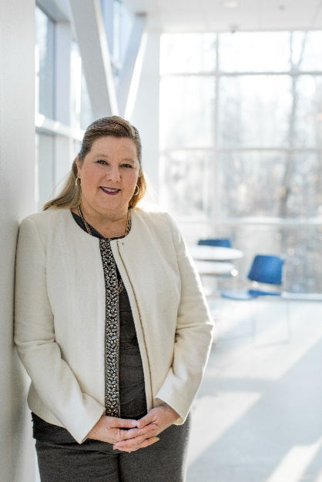
Erin graduated in 1993 from Florida State University with a double major in Political Science and Communications. In 1997, she graduated from the University of Baltimore, School of Law. Following law school, Erin clerked in Anne Arundel Circuit Court for the Honorable James C. Cawood, Jr. After her clerkship, she began her private practice in family law with Dalnekoff & Mason, P.A. in 1998. In 2008, she left private practice to work for Department of Family Administration with the Administrative Office of the Courts. After leaving the Administrative Office of the Courts in 2010, she started working for the Legal Studies Institute with Anne Arundel Community College and in 2017 was elevated to Interim Director and became the permanent Director in November 2018.

The Legal Studies Institute offers associate degrees and certificates in Paralegal Studies, an associate degree in Law and Jurisprudence as well as offering a large selection of continuing legal education programs. The Paralegal Studies Program is approved by the American Bar Association.

Erin is active in many professional organizations, including the Anne Arundel County Bar Association, and the Maryland State Bar Association and been active in committee work.

Associations, Bar Membership
Maryland State Bar Association (“MSBA”), Member in Good Standing (1997 – present)
Anne Arundel County Bar Association (“AABA”), Member in Good Standing (1998 - present)

Present Bar Committees:
- MSBA, ADR Section Council, Council Member (2018 – present)
- MSBA, Bench/Bar Section Council, Council Member (2011 –present)
    - Chair (2016 – 2018)
    - Secretary (2014 – 2016)
Past Bar Association Committees:
- MSBA, Standing Committee on Legal Specialization, Committee Member (2014 –2016)
    - Secretary (2014 –2016)
- MSBA, Family Law Section Council, Council Member (2005 –2011)
    - Chair CLE (2007/2008), (2008/2009), (2009/2010), (2010/2011)
    - Co-Chair Legislation (2006/2007)
- MSBA, Ad Hoc Committee on Pro Se (in conjunction with the Administration Section Council) 2008 - 2010
- AABA, Family Law Committee, Chair (2008/2009, 2009/2010)
- AABA, Family Law Committee, Vice Chair (2010/2011) (2012/2013) (2013/2014)
- AABA, Pro Bono Committee, (2008/2009)
- Women’s Bar Association of Maryland, Inc., Anne Arundel Chapter (2005 –2013)
    - Judicial Nominating Commission (2007/2008), (2008/2009)
    - Interim Executive Board (2005 – 2007)
- Paca/Brent Inns of Court (1998-1999, 1999-2000)

