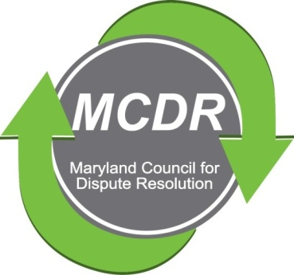

MINUTES OF THE MEETING OF THE BOARD OF DIRECTORS

Wednesday, August 14, 2019

PRESENT: Stirling Phillips, Barry Weissman, Merry Lymn, Janne Weissman, Ramona Buck met at the home of Merry Lymn. Monette Goodridge, Liz Salter and David Lewis participated by telephone.

NOT PRESENT: Thom McCloud.

The meeting of the Board of Directors of the Maryland Counsel for Dispute Resolution was called to order at 6: 45 pm.

TREASURER'S REPORT: The report was sent by e-mail prior to the meeting. There was no discussion.

SEPTEMBER QUARTERLY MEETING: The Board decided that, the quarterly meeting should be a Sunday in September at 2:00 in the afternoon--perhaps in Annapolis. David will look for a venue and a date--the date will not be September 29 because it is Erev Rosh Hashanah.

The topic of the meeting will be "ADR in a Box" with a presentation by John Greere. There is a video that participants should watch beforehand. The video will be available on Barry's laptop during the half hour before the meeting.

NOMINATIONS: Barry, Merry and Stirling will serve as the nominating committee.
Stirling canvassed board members to obtain their preferences for next year. David would like to be Vice President or Chair of the Certification Committee. Ramona would like to be an At-Large Member of the Board.
Stirling asked that the remaining board members e-mail him with their preferences--first and second choices. After the board members have stated their preferences, the nominations will be open to the general membership.
MEMBERSHIP: Janne wrote two letters.
One letter is designed to be sent to the Society of Human Resources members. The purpose of the letter is to publicize MCDR, to explain that MCDR professionals are available to help with workplace conflicts, and to invite Society of Human Resources members to our free quarterly meetings.
The other letter is to MCDR former members who did not renew their membership status. The letter invites these people back to the organization.
Shortly after the meeting, Stirling sent copies of both letters by e-mail. Board members reacted favorably to them.
SHARON PICKETT AWARD: Monette is putting the finishing touches on the video of the presentation of the Sharon Pickett Award. There will be a longer version that will be used for tabletop marketing and a shorter (three to five minutes) to be placed on the MCDR website.
CERTIFICATION COMMITTEE: Ramona passed out copies of the minutes of the certification committee's meeting held on August 5, 2019. Copies are scanned in and attached to the same e-mail as Minutes of this board meeting. Point of clarification: the certification committee will be offering an opportunity for assessment to provide feedback to become a better mediator. This assessment will not be part of the certification process.
Also, a person does not need to be certified to serve on the certification committee, as that committee works on facilitating certifications. Certification is determined by two assessors who have already been certified.
COPYRIGHT: The Board decided that it would be a good idea to place the copyright symbol on MCDR materials. This would be applied to the logo and the training and other materials on the MCDR website.
It appears that there may be people using MCDR materials for certification assessment. It was decided that if someone is getting paid to put on a program using these materials and/or the MCDR process, the payment should be made directly to MCDR and MCDR would then pay the presenters out of that fee.
Mentoring Program: At our last quarterly meeting, several people signed up to be members. Janne and Liz need to go through the participant list to find the names of the volunteer mentors.
A new member, Jamie Brookes, who has considerable experience as a mediator, has volunteered to work on the mentoring program. Stirling will contact her in order to cement this offer.
CALENDAR: The board decided that it would be a good idea to set the calendar a year in advance. Determine the date of quarterly meetings and then look for a topic and venue. This would allow for greater publicity. Merry had the experience of phoning the Maryland Bar and the Daily Record only to find that it was too late to have our meeting announced. If we have the dates, we can contact several publications to place our meetings on their calendars.
NEXT BOARD MEETING: Thursday, September 5, 2019 at 7:00 p.m. The meeting will be conducted by phone.
Respectfully submitted,

Merry Lymn, Secretary

